Lab 06: Abstract Classes, Interfaces and Comparators
Student Name: Jichichi Clive T
Registration Number: H250254B
Programme: Software Engineering
Date: 10/10/2026
Exercise 1: Abstract Classes and Inheritance
Aim: To demonstrate abstraction and method overriding in Java.
Source Code
Shape.java

package lab06abstractinterfaces;

// Abstract class representing a general shape
public abstract class Shape {

// Abstract methods: subclasses must implement these
public abstract double area();

public abstract double perimeter();
}
Circle.java

package lab06abstractinterfaces;

public class Circle extends Shape {

private double radius;

public Circle(double radius) {
this.radius = radius;
}

@Override
public double area() {
return Math.PI * radius * radius;
}

@Override
public double perimeter() {
return 2 * Math.PI * radius;
}
}
Rectangle.java

package lab06abstractinterfaces;

public class Rectangle extends Shape {

private double length;
private double width;

public Rectangle(double length, double width) {
this.length = length;
this.width = width;
}

@Override
public double area() {
return length * width;
}

@Override
public double perimeter() {
return 2 * (length + width);
}
}
Square.java

package lab06abstractinterfaces;

public class Square extends Shape {

private double side;

public Square(double side) {
this.side = side;
}

@Override
public double area() {
return side * side;
}

@Override
public double perimeter() {
return 4 * side;
}
}
Main.java

package lab06abstractinterfaces;

public class Main {

public static void main(String[] args) {

Shape circle = new Circle(5);
Shape rectangle = new Rectangle(6, 4);
Shape square = new Square(4);

System.out.println("CIRCLE");
System.out.printf("Area: %.2f%n", circle.area());
System.out.printf("Perimeter: %.2f%n", circle.perimeter());

System.out.println("\nRECTANGLE");
System.out.printf("Area: %.2f%n", rectangle.area());
System.out.printf("Perimeter: %.2f%n", rectangle.perimeter());

System.out.println("\nSQUARE");
System.out.printf("Area: %.2f%n", square.area());
System.out.printf("Perimeter: %.2f%n", square.perimeter());
}
}
Output
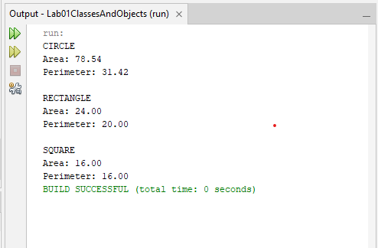
Explanation: An abstract class named Shape was created with abstract methods area() and perimeter(). The Circle, Rectangle and Square classes extended Shape and provided their own implementations of these methods. A main program tested the calculations for each shape.
Conclusion: The exercise demonstrated how abstract classes define a common structure while allowing subclasses to provide their own implementations.

Lab 06 – Exercise 2: Interfaces
Aim: To demonstrate how interfaces allow unrelated classes to implement a common behaviour.
Source Code
Flyable.java

package lab06abstractinterfaces;

public interface Flyable {

void fly();
}
Bird.java

package lab06abstractinterfaces;

public class Bird implements Flyable {

@Override
public void fly() {
System.out.println("The bird flies by flapping its wings.");
}
}
Aeroplane.java

package lab06abstractinterfaces;

public class Aeroplane implements Flyable {

@Override
public void fly() {
System.out.println("The aeroplane flies using its engines.");
}
}
Main.java

package lab06abstractinterfaces;

public class Main {

public static void main(String[] args) {

Flyable bird = new Bird();
Flyable aeroplane = new Aeroplane();

bird.fly();
aeroplane.fly();
}
}
Output
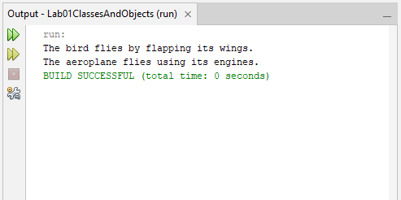
Explanation: A Flyable interface was created with the fly() method. Both Bird and Aeroplane implemented the interface and provided their own versions of the method. The main program called fly() on both objects through Flyable references.
Conclusion: Interfaces allow unrelated classes to follow the same contract while implementing behaviour differently.

Lab 06 – Exercise 3: Abstract Account Class
Aim: To demonstrate the use of abstract classes, concrete methods and method overriding.
Source Code
Account.java

package lab06abstractinterfaces;

public abstract class Account {

protected double balance;

public Account(double balance) {
this.balance = balance;
}

// Concrete method shared by all account types
public void deposit(double amount) {
if (amount > 0) {
balance += amount;
System.out.println("Deposited: $" + amount);
} else {
System.out.println("Deposit amount must be positive.");
}
}

// Each account type defines its own monthly fee
public abstract double monthlyFee();

public double getBalance() {
return balance;
}
}
SavingsAccount.java

package lab06abstractinterfaces;

public class SavingsAccount extends Account {

public SavingsAccount(double balance) {
super(balance);
}

@Override
public double monthlyFee() {
return 2.00;
}
}
CurrentAccount.java

package lab06abstractinterfaces;

public class CurrentAccount extends Account {

public CurrentAccount(double balance) {
super(balance);
}

@Override
public double monthlyFee() {
return 5.00;
}
}
Main.java

package lab06abstractinterfaces;

public class Main {

public static void main(String[] args) {

Account savings = new SavingsAccount(100);
Account current = new CurrentAccount(200);

savings.deposit(50);
current.deposit(100);

System.out.println("\nSAVINGS ACCOUNT");
System.out.println("Balance: $" + savings.getBalance());
System.out.println("Monthly fee: $" + savings.monthlyFee());

System.out.println("\nCURRENT ACCOUNT");
System.out.println("Balance: $" + current.getBalance());
System.out.println("Monthly fee: $" + current.monthlyFee());
}
}
Output
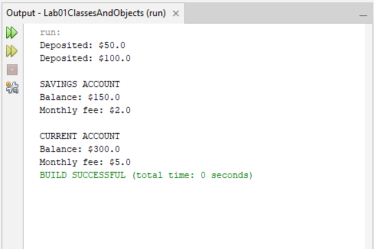
Explanation: An abstract class named Account was created with a balance, a concrete deposit() method and an abstract monthlyFee() method. SavingsAccount and CurrentAccount extended the class and implemented different monthly fees.
Conclusion: Abstract classes allow related classes to share common functionality while providing their own specific implementations where necessary.

Lab 06 – Exercise 4: Comparable and Comparator
Aim: To demonstrate sorting objects using Comparable and Comparator.
Source Code
Student.java

package lab06abstractinterfaces;

public class Student implements Comparable<Student> {

private String name;
private double marks;

public Student(String name, double marks) {
this.name = name;
this.marks = marks;
}

public String getName() {
return name;
}

public double getMarks() {
return marks;
}

// Default sorting: alphabetical order by name
@Override
public int compareTo(Student other) {
return this.name.compareToIgnoreCase(other.name);
}

@Override
public String toString() {
return name + " - " + marks + " marks";
}
}
Main.java

package lab06abstractinterfaces;

import java.util.ArrayList;
import java.util.Collections;
import java.util.Comparator;

public class Main {

public static void main(String[] args) {

ArrayList<Student> students = new ArrayList<>();

students.add(new Student("Tendai", 75));
students.add(new Student("Brian", 88));
students.add(new Student("Angela", 92));
students.add(new Student("Farai", 67));

// Sort using Comparable: alphabetical order by name
Collections.sort(students);

System.out.println("SORTED BY NAME:");
for (Student student : students) {
System.out.println(student);
}

// Sort using Comparator: marks from lowest to highest
Comparator<Student> byMarks =
Comparator.comparingDouble(Student::getMarks);

Collections.sort(students, byMarks);

System.out.println("\nSORTED BY MARKS:");
for (Student student : students) {
System.out.println(student);
}
}
}
Output
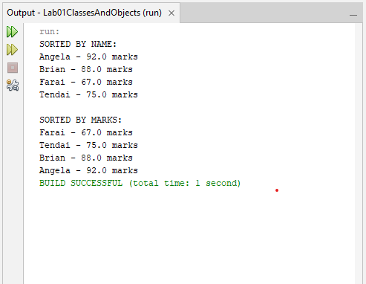
Explanation: The Student class implemented Comparable<Student> to sort students alphabetically by name using compareTo(). A separate Comparator<Student> was created to sort students by marks in ascending order. The Collections.sort() method was used to perform both sorts.
Conclusion: Comparable defines a class's natural ordering, while Comparator allows different sorting criteria without changing that natural ordering.

Lab 06 – Exercise 5: Conflicting Default Methods
Aim: To demonstrate how Java resolves conflicts between default methods in multiple interfaces.
Source Code
InterfaceA.java

package lab06abstractinterfaces;

public interface InterfaceA {

default void hello() {
System.out.println("Hello from Interface A");
}
}
InterfaceB.java

package lab06abstractinterfaces;

public interface InterfaceB {

default void hello() {
System.out.println("Hello from Interface B");
}
}
Greeting.java

package lab06abstractinterfaces;

public class Greeting implements InterfaceA, InterfaceB {

@Override
public void hello() {
System.out.println("Resolving the default method conflict:");

InterfaceA.super.hello();
InterfaceB.super.hello();
}
}
Main.java

package lab06abstractinterfaces;

public class Main {

public static void main(String[] args) {

Greeting greeting = new Greeting();

greeting.hello();
}
}
Output
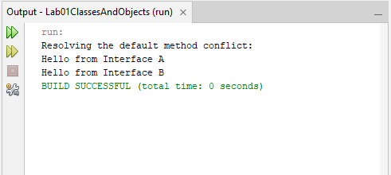
Explanation: Two interfaces, InterfaceA and InterfaceB, were created with default methods named hello(). The Greeting class implemented both interfaces and overrode hello() to resolve the conflict. The methods InterfaceA.super.hello() and InterfaceB.super.hello() were used to call both default implementations explicitly.
Conclusion: Java requires a class to resolve conflicting default methods from unrelated interfaces by overriding the method. The InterfaceName.super syntax allows the class to access a specific interface's default implementation.

